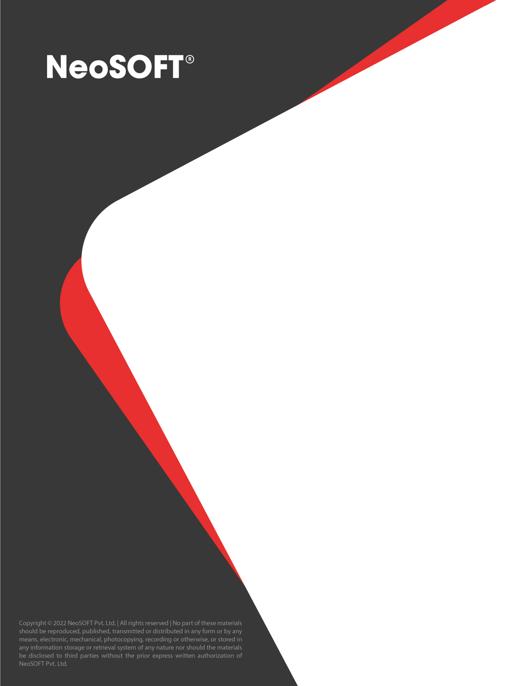

Real Estate Valuation Management System

**Eltizam**

Client Name

Project Name

**BUSINESS PROPOSAL**

November 1, 2022

NeoSOFT is a SEI-CMMI Level-5 Global IT Consulting & Software Solutions Provider

|  |  |
| --- | --- |
| **Document Control Sheet** | |
| **Current Version** | 1.2 |
| **Project Code** | NS_EOREMAD_26072022 |
| **Project Name** | Real Estate Valuation Management System |
| **Document Type** | Understanding Document |
| **Author** | Pragadesh |
| **Reviewed By** | Amol |
| **Contact Person** | Sean |
| **Frequency of Document Review** | Next Revision of Standard Documents |
| **Document Creation Date** | 26-07-2022 |
| **Last Updated Date** | 01-11-2022 |

|  |  |  |  |
| --- | --- | --- | --- |
| **Revision History** | | | |
| **Version** | **Date** | **Name** | **Comments** |
| 1.0 | 26-07-2022 | Pragadesh | Proposal Document |
| 1.1 | 26-08-2022 | Pragadesh | Updated timeline and scope |
| 1.2 | 01-11-2022 | Pragadesh | Revised Scope (Removed Broker Management Process) |

Contents

1 EXECUTIVE SUMMARY 5

1.1 About Us 5

2 SCOPE 6

2.1 Overview 6

2.2 In-Scope Features/Services 6

3 IMPLEMENTATION APPROACH 8

3.1 Technology Architecture 8

3.2 Technology/Environment Specifications 9

3.3 Final Deliverables 11

3.4 Functional/Technical Implementation 12

3.4.1 Functional Understanding 12

3.4.2 Work Breakdown Structure 23

3.4.3 Implementation Methodology 32

3.4.4 Testing Methodology 34

3.4.5 Business Analysis 38

3.4.6 UAT Support Process 38

3.4.7 Training Process 40

3.4.8 Production Deployment 40

3.5 Our Value Adds 41

4 ASSUMPTIONS & CONSTRAINTS 42

4.1 Project Specific 42

4.2 Out of Scope 43

4.3 Generic 43

5 PROJECT TIMELINE 44

6 PROJECT REPORTING AND GOVERNANCE 45

7 RISKS AND MITIGATION PLAN 46

8 FEES AND PAYMENTS 47

9 CHANGE MANAGEMENT 49

10 STANDARD TERMS AND CONDITIONS 52

11 OUR DETAILED PORTFOLIO 55

# EXECUTIVE SUMMARY

NeoSOFT is pleased to present **Eltizam** with this business proposal to provide **Development of Real Estate Valuation Management System** engagement. Having duly examined your needs and business situations, we are confident that our proposed services/solutions will suffice to cater to the requirements. We look forward to forming a mutually rewarding relationship.

## About Us

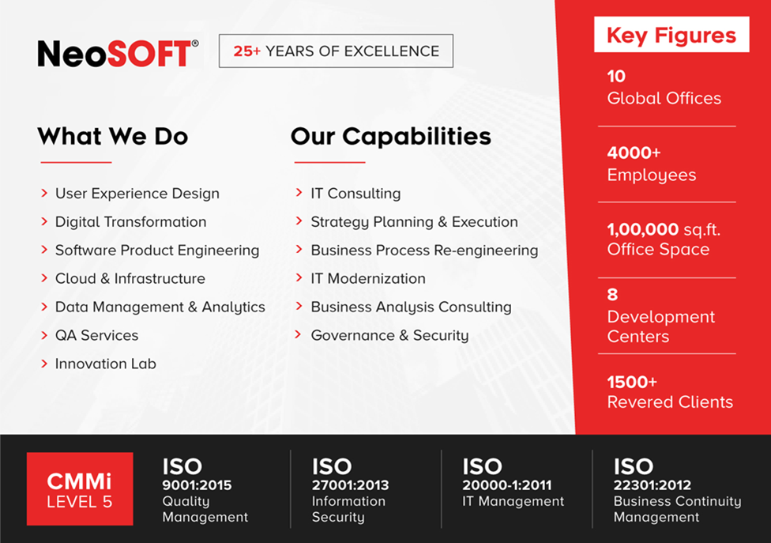

# SCOPE

## Overview

The client wants to develop a web application to manage the process as a) valuation & Evaluation process with dashboard and reports. On this application we have Super Admin user who can manage the entire process as valuation process, financial management, manage quotation, invoices, Masters, dashboards and reports. We have three levels of approvals for each process that will manage with roles and access permissions.

* Web – Super Admin User

## In-Scope Features/Services

Based on our understanding, the following is the high-level scope for this engagement:

* Requirement Study
* Design
* Development
  + Web App – Super Admin User
    - Login
    - Forget Password
    - Dashboard
    - Manage Department
    - Manage Sub Admin
    - Roles and Access Permissions
    - Valuation Process
      * Master
        + Location
        + Client
        + External Vendors
        + Projects
        + Valuation Approver
        + External Valuation Approver
        + History
        + Currency
        + Approval Master
      * Valuation Request creation
      * View created Request with Approval / Rejection (Approver 1)
      * View created Request with Approval / Rejection (Approver 2)
      * Manage Quotation
      * Manage Payment
      * Terms of Engagement
      * Evaluation Process
      * Valuation Instructor Screen
      * Site Description Screen
      * Comparable Evidences
      * Valuation Assessment
      * Relevant Documents
      * View valuation Request Internal Approval / Rejection
    - Notifications
    - Reports
    - Log out
* QA Services
* Deployment
* UAT Support
* Training
* Project Management
* Documentations

# IMPLEMENTATION APPROACH

## Technical Architecture

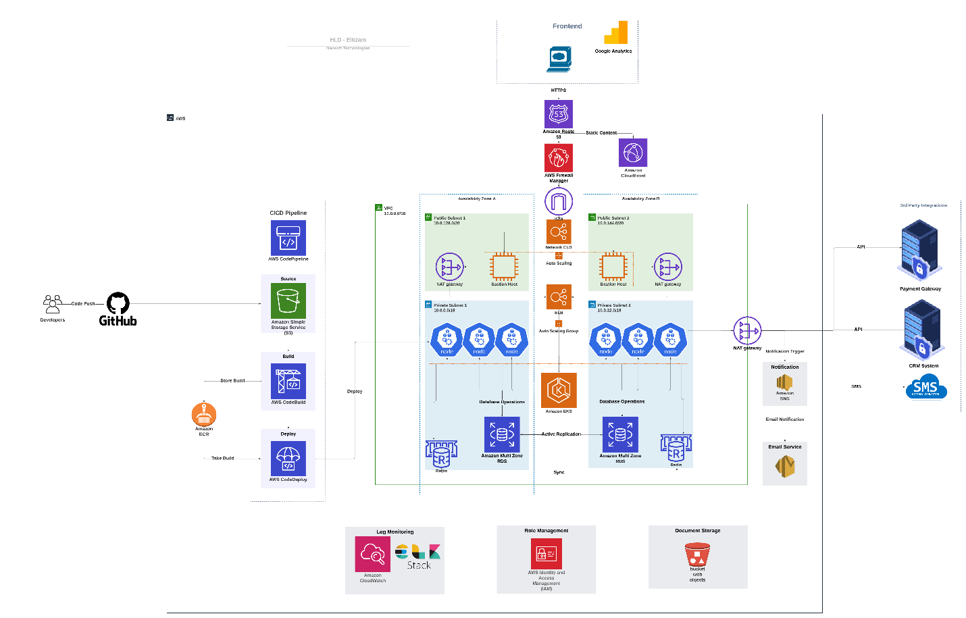

## Technology/Environment Specifications

|  |
| --- |
| **Technology/Environment Stacks** |
| * Environment   + Dev Environment: NeoSOFT   + UAT Environment: NeoSOFT   + PROD Environment: Client * Platforms   + Web * Framework   + .NET Framework * Application Development   + Web     - Razor Forms (.NET Core MVC)     - C#. NET   + MS SQL * Third-party Integrations   + SMS Gateway - Appropriate SMS notification should be sent to the respective users.   + Email Integration - Appropriate Email notification should be sent to the respective users.   + Payment Gateway Integration – To manage payments. * Browser Versions supported  |  |  |  | | --- | --- | --- | | **Browser** | **Version** | **Operating System** | | Microsoft Edge | 87.0.664.52 | Windows & Linux | | Mozilla Firefox | Firefox 81 and above | Windows & Linux | | Google Chrome | Google Chrome 83 and above | Windows & Linux | | Safari | Safari 12 and above | Mac OS | |

## Final Deliverables

|  |
| --- |
| **Final Deliverables** |
| * Analysis Design Phase   + Wireframe   + SRS * Design   + Web App Design * Development   + Web Application   + Database structure   + Unit testing report * QA   + Test Plan   + Test Cases   + Functional testing report * Training   + User Manual   + Training Session |

## Functional/Technical Implementation

### Functional Understanding

**Modules – Super Admin User (Web App)**

**Login**

* User will be login into the application with given username / password.

**Forget Password**

* User will be able to reset the password if they forgot the old password
* On clicking of “Forget password” link in login screen, user will receive the email with change password link on registered email id.
* On clicking of “Change password” link, user will create a new password.

**Manage Department**

* User will be able to create / edit/ view /active / de active the department details.
* User will have search option to search the created department details.
* The department details as 5 – 10 text fields / dropdown data types.
* User will be able to view the list of created department details.

**Manage Sub Admin**

* User will be able to create / edit/ view /active / de active the sub-admin details.
* User will have search option to search the created sub-admin details.
* The sub admin details as 5 – 10 text fields / dropdown data types as name, username / email, password, mobile number with 6 fields.
* User will be able to view the list of created sub admin details.

**Manage Roles and Access Permissions**

* User will be able to create / edit/ view /active / de active the roles and access permission details.
* User will have search option to search the created roles with permission details.
* The roles details as 5 – 10 text fields / dropdown data types as role name, role description with 2 fields.
* While creating role user will be able to create permissions as create / edit / view / approve / reject for particular submitted applications or features.
* User will be able to view the list of created roles with permission details.

**Valuation Process**

**Dashboard**

* Users will be able to view the overview of the proposal status, revenue generation, project performance, Management details, client details and analyst details.
* User will be able to view the 4 graphical reports based on the above details.
* The graphical reports as Bar chart, pie chart or tabular column.

**Note:** We assume the reports data and the overview will be provided by client.

* **Masters**
* **Location Master**
  + - User will be able to create / edit/ view /active / de active the created location details.
    - User will have search option to search the created location details.
    - The location details as 5 – 10 text fields / dropdown data types.
    - User will be able to view the list of created location details.
* **Client Master**
  + - User will be able to create / edit/ view /active / de active the created client details.
    - User will have search option to search the created Client details.
    - The Client details as 5 – 10 text fields / dropdown data types.
    - User will be able to view the list of created client details.
* **External Vendor Master**
  + - User will be able to create / edit/ view /active / de active the created vendor details.
    - User will have search option to search the created Vendor details.
    - The Vendor details as 5 – 10 text fields / dropdown data types.
    - User will be able to view the list of created vendor details.
* **Project Master**
  + - User will be able to create / edit/ view /active / de active the created project details.
    - User will have search option to search the created project details.
    - The project details as 5 – 10 text fields / dropdown data types.
    - User will be able to view the list of created project details.
    - While creating project, user will be able to map the type of property and type of client and location
    - User will be able to create multiple projects under type of client and type of property
* **Valuation Approver Master**
  + - User will be able to create / edit/ view /active / de active the created valuation approver details.
    - User will have search option to search the created valuation approver details.
    - The valuation approver details as 5 – 10 text fields / dropdown data types.
    - User will be able to view the list of created valuation approver details.
    - User will be able create the hierarchy of approvals.
* **External Valuation Approver Master**
  + - User will be able to create / edit/ view /active / de active the created external valuation approver details.
    - User will have search option to search the created external valuation approver details.
    - The external valuation approver details as 5 – 10 text fields / dropdown data types.
    - User will be able to view the list of created external valuation approver details.
* **History of Existing Data Master**
  + - User will be able to create / edit/ view /active / de active the created history of existing data details.
    - User will have search option to search the created history of existing data details.
    - The history of existing data details as 5 – 10 text fields / dropdown data types.
    - User will be able to view the list of created history of existing data details.
* **Currency Master**
  + - User will be able to create / edit/ view /active / de active the created currency details.
    - User will have search option to search the created currency details.
    - The currency details as 5 – 10 text fields / dropdown data types.
    - User will be able to view the list of created currency details.
* **Approval Master**
  + - User will be able to create / edit/ view /active / de active the approval details.
    - User will have search option to search the created approval details.
    - The approval details as 5 – 10 text fields / dropdown data types.
    - User will be able to view the list of created approval details.
* **Valuation Request (Creator)**
  + - User will be able to create / edit/ view the valuation request details.
    - User will have search option to search the created valuation request details.
    - The valuation request details have the following
      * Date
      * Valuation reference no (auto generated)
      * Other numbers
      * Location
      * Area
      * Entity Name
      * Applicant name
      * Property address as address 1, 2, city, country
      * Project Name
      * User type
      * User sub type
      * Property type
      * Valuation purpose
      * Method of valuation
      * Status of valuer
      * Property interest
      * Valuation date
      * Fees
      * Valuation status
        + New (request raised as fresh)
        + Accepted – (First level of approver approves the submitted application)
        + Quotation Submitted – (Proposal submitted to client / entity)
        + Approved – (Final level of approver approves the submitted application)
        + Rejected – Reject the request for edition
        + Cancelled – Request has been cancelled
        + Under Valuation – valuer is validating the records
        + Completed – Request is completed.
      * Valuation time frame (start date & end date)
    - User will be able to view the list of created request with above mentioned details.
    - User will be able to edit the valuation request details if the particular submission is rejected.
* **View created Request with Approval / Rejection (Approver 1)**
  + - User will be able to view the valuation request details along with status and approver name / email and notes.
    - User will be able to view the Approve or Reject button and have option to add notes while approving or rejecting the submissions.
    - User will have search option to search the approved / rejected valuation request details.
* **View created Request with Approval / Rejection (Approver 2)**
  + - User will be able to view the valuation request details along with status and approver name / email and notes.
    - User will be able to view the Approve or Reject button and have option to add notes while approving or rejecting the submissions.
    - User will have search option to search the approved / rejected valuation request details.
* **Manage Quotation**
  + - User will be able to create / edit/ view the quotation details.
    - User will have search option to search the created quotation details.
    - User will be able to create quotation based on project / client
    - The quotation details has the following details
      * Entity fees
      * Discounts if any
      * Currency
      * Valuation fees
      * VAT
      * TAX
      * Other charges
      * Valuation instructor charges
      * Total fees
      * Status (sent, pending)
    - User will be able to view the list of created quotation details.
    - User will be able to add the multiple quotes.

**Note:** Once the quotation is sent user is will not be able to edit the details

* **Manage Payment**
  + - User will be able to add / view the payment details.
    - User will have search option to search the created payment details.
    - User will be able to create quotation based on project / client
    - The payment details has the following
      * + Entity fees
        + Discounts if any
        + Currency
        + Valuation fees
        + VAT
        + TAX
        + Other charges
        + Valuation instructor charges
        + Total fees
        + Status (sent, pending)
    - User will be able to create invoice based on the above details and have option to print or download or share the invoice.
    - User will be able to get the payments online and record the payment.
    - Once the payment is received user will be able to add / edit the payment details and generate or download receipt.
    - User will be able to view the list of created department details.
* **Manage Terms of Engagement**
  + - User will be able to add / view the terms of engagement details.
    - Once the user got approval from customer, they will share the terms of engagement details via mail along with quotation.
    - User will have search option to search the created terms of engagement details.
* **Valuation Instructor Screen**
  + - User will be able to view this once the approval is completed and status should show as “Under valuation” with following details
      * Valuer Name
      * Qualification
      * Position
      * Add Municipality Number
* **Site Description Screen**
  + - User will be able to create / edit/ view /delete the site description details.
    - User will be able to view this once the approval is completed and status should show as “Under valuation” with following details
      * Structural information
      * Developer information
      * External information
      * Condition notes
      * Addition information notes
      * Other notes
      * Relevant documents
      * Add location for inspections.
    - User will have search option to search the created site description details.
    - User will be able to view the list of created site description details.
* **Comparable Evidences Screen**
  + - User will be able to create / edit/ view /delete the evidence details.
    - User will be able to upload the relevant documents.
    - User will have search option to search the created site description details.
    - User will be able to view the list of uploaded evidence details with comments
* **Valuation Assessment Screen**
  + - User will be able to create / edit/ view /delete the assessment details.
    - User will be able to upload the relevant documents.
    - User will have search option to search the created assessment details.
    - User will be able to view the list of uploaded assessment details with data as market value, life of building, market Ren, AMC, insurance
* **Relevant Documents Screen**
  + - User will be able to upload / view /delete the document details.
    - User will be able to upload the relevant documents against the customer.
    - User will be able to view the list of uploaded document details
* **View valuation Request Internal Approval / Rejection** 
  + - User will be able to view the valuation request details along with status and approver name / email and notes.
    - User will be able to view the Approve or Reject button and have option to add notes while approving or rejecting the submissions.
    - User will have search option to search the approved / rejected valuation request details.

**Notifications**

* User will be able to view the notifications based on certain triggers.
* We have considered 5 -6 notification triggers.
* Users will be able to receive in app notifications.

**Reports**

* User will be able to view the maximum of 6 reports as follows. All the reports will be displayed in a grid table format and there will be a download option (excel) available.
  + Client wise report
  + Project wise report
  + Project Location wise report
  + Project type report
  + Project status report

Note: All the above reports will be filter based on a start date, due date, project, location, client, project owner, type of property, purpose of valuation.

Note: We have not considered any Adhoc reports apart from the ones mentioned above.

**Logout**

* User will be logged out from the application.

**Document management System**

* User will be able to upload/import document in from of PDF, JPEG, JPG, and Word formats.
* We will fetch Data/Details from the uploaded documents as per certain criteria/parameters. This ensures that we will fetch selective data to the system and not the whole document as is
* User will be able to view data, update data, delete data
* User will be able to further extract/export selected data to PDF, CSV and Excel document format.

**Note:**

* We assume document details/data in the source format will have a predefined structure. We will consider predefined format document to be processed to further generate readable data on the system.
* We will only support certain data formats for import and export - PDF, JPEG, JPG, and Word for import and PDF, CSV, Excel format for export
* User will not be able to add additional fields.
* Exported data will be viewed in a Tabular/Grid format.

### Work Breakdown Structure

Based on the above understanding, following is the work breakdown which we have identified for this current implementation.

|  |  |  |  |  |
| --- | --- | --- | --- | --- |
| **Sr. No.** | **Interface** | **Modules/Sub Modules** | **Features / Tasks** | **Assumptions** |
|  | **Project Setup** |  |  | As discussed with SA team, we will have service oriented architecture for this, where we will have REST based API and front end as MVC. |
|  |  |  |  | ERP/CRM integration is not considered in this estimation, as mentioned in scope ERP/Existing CRM integration will be in phase 2 |
| 1 | **Super Admin User (Custom)** | **Login** | User will be login into the application with given username / password. | considering 1 page with user name and password text inputs |
|  |  | **Forget Password** |  | considering 2 page with option of enter email and reset password |
|  |  | **Dashboard** | To view the overview of the proposal status, revenue generation, project performance, Management details, client details and analyst details. | Assuming we will have mostly tabular data & some bar / pie charts |
|  |  | **Manage Department** | User will be able to create / edit/ view /active / de active the department details. There will be 5-10 text fields. and user will be able to view it | Assuming we will have 5/7 fields entry form and will have only 1/2 cascade dropdowns |
|  |  | **Manage Sub Admin** | User will be able to create / edit/ view /active / de active the Sub admin details. There will be 5-10 text fields. and user will be able to view it | Assuming we will have 5/7 fields entry form and will have only 1/2 cascade dropdowns |
|  |  | **Roles and Access Permissions** | User will be able to create / edit/ view /active / de active the roles and access permission details. |  |
|  | **Valuation Process** | **Master** |  |  |
|  |  | **Location** | User will be able to create / edit/ view /active / de active / search the created location details. | Assuming we will have 5/7 fields entry form and will have only 1/2 cascade dropdowns |
|  |  | **Client** | User will be able to create / edit/ view /active / de active / search the client details. | Assuming we will have 5/7 fields entry form and will have only 1/2 cascade dropdowns |
|  |  | **External Vendors** | User will be able to create / edit/ view /active / de active / search the created external vendor details. | Assuming we will have 5/7 fields entry form and will have only 1/2 cascade dropdowns |
|  |  | **Projects** | User will be able to create / edit/ view /active / de active / search the created project details. | Assuming we will have 5/7 fields entry form and will have only 1/2 cascade dropdowns |
|  |  | **Valuation Approver** | User will be able to create / edit/ view /active / de active / search the created valuation approver details. | Assuming we will have 5/7 fields entry form and will have only 1/2 cascade dropdowns |
|  |  | **External Valuation Approver** | User will be able to create / edit/ view /active / de active / search the created external valuation approver details. | Assuming we will have 5/7 fields entry form and will have only 1/2 cascade dropdowns |
|  |  | **History** | User will be able to create / edit/ view /active / de active / search the created history details. | Assuming we will have 5/7 fields entry form and will have only 1/2 cascade dropdowns |
|  |  | **Currency** | User will be able to create / edit/ view /active / de active / search the currency details. | Assuming we will have 5/7 fields entry form and will have only 1/2 cascade dropdowns |
|  |  | **Approval Master** | User will be able to create / edit/ view /active / de active / search the approval master details. | Assuming we will have 5/7 fields entry form and will have only 1/2 cascade dropdowns |
|  |  | **Valuation Request creation** |  |  |
|  |  | **View created Request with Approval / Rejection (Approver 1)** | page which includes list and detail view with the option of approve , reject ,notes and search option |  |
|  |  | **View created Request with Approval / Rejection (Approver 2)** | page which includes list and detail view with the option of approve , reject ,notes and search option |  |
|  |  | **Manage Quotation** | 2 to 3 page which includes list view, create, edit, view details, search . | Assuming we will have 5/7 fields entry form and will have only 1/2 cascade dropdowns |
|  |  | **Manage Payment** | Manage Invoice and Receipt were user can view list view, detail of payment and receipt generation of payment |  |
|  |  | **Terms of Engagement** | User will be able to add / view the terms of engagement details. Share via mail along with proposal |  |
|  |  | **Evaluation Process** |  |  |
|  |  | **Valuation Instructor Screen** | View detail page with the status of valuation |  |
|  |  | **Site Description Screen** | User will be able to create / edit/ view /delete the site description details. |  |
|  |  | **Comparable Evidences** | User will be able to create / edit/ view /delete the evidence details and upload relevant documents |  |
|  |  | **Valuation Assessment** | User will be able to create / edit/ view /delete the assessment details and upload relevant documents |  |
|  |  | **Relevant Documents** | User will be able to upload / view /delete the document details. |  |
|  |  | **View valuation Request Internal Approval / Rejection** | User will be able to view / approve / reject the valuation request details along with status and approver name / email and notes. |  |
|  |  | **Notifications** | User will be able to view the notifications related to creation approval status and other notification if any. |  |
|  |  | **Reports** | User will be able to view the 5 –6 reports based on the process and projects. | Assuming maximum 5- 6 reports with having mostly tabular data |
|  |  | **Log out** |  |  |
| 4 | **Others** | **Document Automation Process** | • User will be able to upload/import document in from of PDF, JPEG, JPG, and Word formats. • We will fetch Data/Details from the uploaded documents as per certain criteria/parameters. This ensures that we will fetch selective data to the system and not the whole document as is • User will be able to view data, update data, and delete data • User will be able to further extract/export selected data to PDF, CSV and Excel document format. Note:  • We assume document details/data in the source format will have a predefined structure. We will consider predefined format document to be processed to further generate readable data on the system. • We will only support certain data formats for import and export - PDF, JPEG, JPG, and Word for import and PDF, CSV, Excel format for export • User will not be able to add additional fields. • Exported data will be viewed in a Tabular/Grid format. | We will integrate third party to achieve this |
|  |  | **SMS Integration** |  |  |
|  |  | **Email Integration** |  |  |
|  |  | **English and Arabic Language** |  |  |
|  |  | **Payment Gateway Integration** |  |  |

### Implementation Methodology

Based on the current understanding and the scope identified, we are proposing a Hybrid Scrum framework implementation methodology and with this Incremental model, multiple development cycles will take place. Cycles are divided up into smaller, more easily managed iterations.  But once the requirement study is completed only, the methodology will be finalized, otherwise, we will follow the traditional Waterfall model wherein all the functional components will be released as part of the final UAT or if the client is open to change the delivery model to T&M engagement then we can adopt a 100% Agile SCRUM methodology for the implementation as well.

**Hybrid Framework**

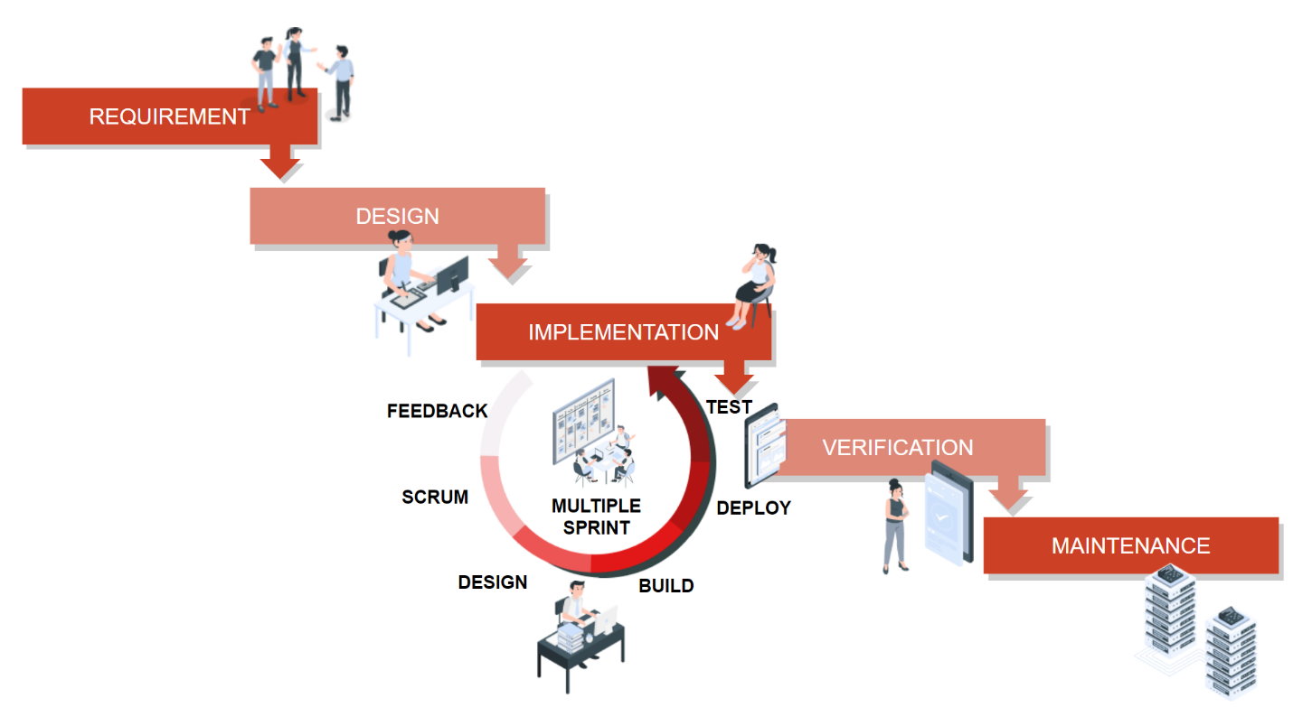

With the Hybrid approach, the below process will be followed.

* Since it’s a fixed bid engagement, all the requirements will be analyzed and signed off as part of the requirement gathering phase. Any new additional requirements identified as part of the iterative releases will be considered as Change Request and this will be executed based on the Change Management Process.
* Each iteration will have multiple releases which comprise design, development, and testing phases.
* A working version of software is produced during the first iteration, so that client will have working software early on during the software life cycle to ensure that the application is getting developed as expected (But the same will not be available for the end customer as it may require dependency modules for enabling the full-fledged functionalities). This hybrid approach facilitates the client to familiarize themselves with the application and avoid the pitfalls of the traditional Waterfall model.
* Generally in this model, the core of the application is built initially and components are added to it as part of each sprint. This permits gradual implementation of the system in small installments and reduces implementation risk.
* On completion of all the modules, we will perform integration testing and subsequently, final build will be available for the customer UAT.

### Testing Methodology

Based on the current scope and understanding we are proposing manual software testing process for this implementation. But if the client is open to enable an automation framework for this implementation, we can leverage our automation team as well. Based on the current scope, automation is considered out of scope, unless it’s stated in this current proposal as one of the scopes of services.

Our Current Scope of Manual Testing Services includes -

* Digital Testing (Web)
* API/Web Services Testing
* Database Testing

**OUR APPROACH**

Our testing process framework uses a structured approach for each phase of testing across SDLC, V model, and Agile framework.

Our proven testing methodology and framework are central to all of our testing engagements and following activities will be taken place as part of the test cycle.

* Test requirements/sprint story collection
* Estimations and pricing
* Planning, and preparation
* Execution
* Reporting
* Retesting
* Test closure

**TEST PROCESS**

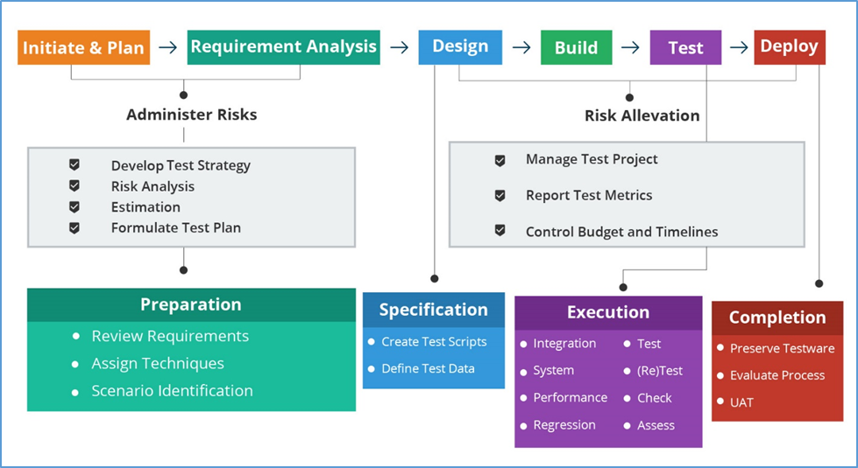

**REQUIREMENT ANALYSIS PHASE**

* The Requirements Analysis Phase incorporates planning and control phases when creating functional requirements. This provides the basis for a manageable and high-quality testing process.
* In this phase testing team goes through the requirement document with both functional and non-functional details in order to identify the testable requirements.
* In case of any queries, the QA team may set up meetings with the clients and the stakeholders (technical leads, business analysts, system architects, clients, etc.) in order to clarify their doubts.
* Once the QA Team is clear with the requirements, they will document the acceptance criteria and get it approved by the customers.

Activities to be done in requirements analysis phase are: -

* Analyzing the system requirement specifications from the testing point of view
* Preparation of RTM (Requirement traceability matrix)
* Identifying the testing techniques and testing types
* Prioritizing the feature which needs focused testing

Deliverables in requirements analysis phase are: -

* Requirement Traceability Matrix Document

**TEST PLANNING PHASE**

* Test Planning is a phase in which a Senior QA Manager determines the test plan strategy along with efforts and cost estimates for the project.
* The resources, Test Environment, Test Limitations, and Testing Schedule are also determined.
* The Test Plan gets prepared and finalized in the same phase.

Activities to be done in test planning phase are: -

* Estimation of testing effort
* Selection of testing approach
* Preparation of Test Plan
* Resource Planning

Deliverables in test planning phase are: -

* Test Plan Document

**TEST DESIGN PHASE**

Activities to be done in test design phase are: -

* Test Scenarios and Test Cases.
* Test Cases Verification
* Creation of Test Data is done in this phase.

Deliverables in test design phase are: -

* Test Scenarios
* Test Cases & Test Data

**TEST EXECUTION PHASE**

* After the Test Case development and Test Environment setup, test execution phase gets started.
* Test Execution phase is the process of executing the code and comparing the expected and actual results

Activities to be done in test execution phase are: -

* Execution of Test Cases and Reporting Test Results & Logging defects
* Verification and retesting of the defect
* Regression Testing
* Closure of Defects

Deliverables in test execution phase are: -

* Test Execution Report
* Updated Test Cases with results
* Bug Report

**TEST CLOSURE PHASE**

* Test Closure is the last stage of software testing life cycle. A report will be prepared by the team manager or lead after the completion of software testing process.
* After the preparation of this report & release of the software, the test closure activities are performed.
* The objective of performing these activities is to determine the actual outcomes and the impact of various testing activities executed on the software to ensure its quality.

Activities to be done in test closure phase are: -

* Checking which planned deliverables have been delivered
* Close Incident Reports
* Handing over the test artifacts
* Preparing document on system acceptance
* Learning experience

Deliverables in test execution phase are: -

* Test Closure Report
* Release Note

### Business Analysis

|  |  |
| --- | --- |
| Mode | Online Remote Sessions |
| Requirement Analysis Duration | 8 weeks |
| Stakeholders’ Availability | Client should provide the SPOC for the discussion & Client SPOC should bring all the relevant stakeholders (Admin/Business Users) for the relevant meetings |
| Single Session Client’s Stakeholders Availability | Min 3-4 hours per day (It may increase depending upon the requirement’s complexity) |
| Deliverables | As mentioned in the Final Deliverables part |

### UAT Support Process

|  |  |
| --- | --- |
| Mode | Online Remote Sessions |
| Environment | NeoSOFT |
| UAT Planned Period | 3 weeks |
| UAT Signoff | 1 week |
| Process | In UAT (User Acceptance Testing), client will validate the application against each Signed Off requirement specification and the same will be implemented as follows;   * Once we have our internal QA Sign-off, the application will be deployed in the staging/UAT server to start the UAT phase accordingly. * The allocated UAT Support Team for this project will provide required guidance and support to the Client Stakeholders to perform the UAT * Assuming that, all the Client stakeholders will be available for the UAT period and our allocated support team will provide the required help to finish the UAT * All the issues raised in the UAT phase will be fixed and deployed based on an interval and our UAT Support Team will help the client team to verify the issues accordingly. * All UAT issues should be logged as and when it occurred and each issue should have a detailed description, including Actual Results, Expected Results, steps to reproduce, and other supporting evidence if any. * As this engagement is a fixed bid model, any Change Requests raised during the UAT (User Acceptance Testing) will be considered only in the next phase as a CR and same would be treated as per change management procedure * We have planned only one round of UAT testing and this phase will be executed on a continuous basis. * Since this is a fixed bid engagement model we will be able to address only the issues which will be raised within the UAT proposed duration as part of the Project timeline. * Assuming that the client SPOC will provide the Sign-off through email, from the concerned stakeholders within the UAT Sign-off period which is mentioned in the Project timeline * Once the UAT duration (UAT Period + UAT Sign-off period) is completed, the warranty period will be started as a continuation as per the Project timeline * The application would be considered as accepted if no issues are raised within the defined UAT period as part of the project timeline * Any delays or non-availability of the client stakeholders which result in an extension for the planned UAT period timeline will be considered as a schedule deviation and will be charged at a mutually agreeable rate. * After the planned UAT period, any additional support requirements are needed the same will be considered as a Change Request on mutually agreeable terms and will be executed with any of the support models as follows.   + Resource Engagement Model   + Bucket Hours   + Managed Service |

### Training Process

|  |  |
| --- | --- |
| Training Mode | Online |
| Training Frequency | One Time |
| Single Session Duration | Max 4 hours |
| Number of Sessions | 3-4 sessions |
| Targeted Audience | Admin/Business User |
| Deliverables | Demo and User Manuals |

### Production Deployment

|  |  |
| --- | --- |
| Deployment Mode | Remote |
| Type of the Environment | For Web Application –Cloud (AWS) |
| Hosting Environment (Procurement) | Client |

## Our Value Adds

Organization-wide, NeoSOFT has implemented the project management and development following the best industry practices and are ISO 9001-2000 complaint. We have compiled the best practices from SEI-CMMi level 5 and Six Sigma Methodology and constantly work towards optimizing our processes and reducing defects.

The Quality Management System (QMS) is based on the NeoSOFT’s philosophy, which focuses on customer satisfaction, results through processes, and the involvement of each team member. The ISO 9001-2000 certification confirms the effectiveness of the QMS and continuous/continual improvement.

While a project is being executed at NeoSOFT, NeoSOFT follows a set of documentation, project development methodology, and testing techniques, some of which can be written down:

* Software Quality Assurance Plan
* Deviations in Software Activities and Software Work Products Procedure
* SQA Reviews Procedure

We ensure that we can quickly and accurately respond to client business requirements, and guarantee on-time delivery. Our schedule variance for the last 3 years (after re-baselining for change requests) is 10 percent.

And for agile projects, our completion rate (percentage of story points finished per sprint) is 90 percent.

CMMI-driven process improvement ensures delivering real cost savings, more effective error detection, and hence reduced cost of remediation. We also ensure effective management of change so clients spend less on re-work, reductions in schedule variability, and increased cost predictability.

# ASSUMPTIONS & CONSTRAINTS

## Project Specific

* Web Application will support English and Arabic language only.
* Static Content (Text, Images, Videos) in required languages, branding guidelines, and logo will be provided by the client.
* If any additional APIs integration which will be identified as part of the analysis phase, will be considered as additional scope and same will be charged accordingly.
* The client will have to bear the cost of all the third-party APIs & extensions required for the development of the proposed system if any. Credentials required for 3rd party integration will be shared by the client. The integration will be done by NeoSOFT.
* All the above such 3rd Party APIs that would be integrated with the proposed system will be provided by the client during analysis phase. (Since the actual API details are not shared at this point in time, implementation time of such APIs maybe differed depends upon the complexity and if it is beyond our proposed timeline, the same will be charged accordingly).
* Supported doc upload/import file types are PDF, JPEG, JPG, DOC, Excel/CSV formats.
* We will provide the list of licenses required (if any) prior to project commencement.
* Custom design will be applied for the Sub Admin Portal .
* Any addition in workflow/feature will affect the given timeline and costing.
* Client will provide the cloud hosting server details. We have not considered hosting cost. NeoSOFT will be responsible to host the solution on client environment.
* Document management system will be limited to integration of any existing DMS via suitable mechanism like APIs or SDKs. NO DMS custom development is part of current scope.
* Any additional modules or workflow will result in additional time & cost. This estimation is based on understanding and listing of modules, it may vary as per reply on queries from client.
* We haven't considered any specific NFRs apart from the default ones for web application.
* We have considered the common business workflow for all types of client as bank, government and private company, assumed the work flow for all user entity type will be same.
* We did not consider the formation of multiple companies under a single company/ client.

## Out of Scope

* We haven't considered mobile application development as part of current scope
* We haven’t considered the existing CRM integration as part of current scope, but the application should have flexibility to integrate with existing CRM / ERP.
* We haven’t considered the broker management process and the portal for broker.

## Generic

* **Eltizam** shall designate a representative/SPOC to be the Primary Contact for this engagement.
* **Eltizam** team shall provide NeoSOFT team with detailed and accurate information regarding its current network environment, server hardware details, software versions, or regulatory requirements. Inaccurate information may add time and cost to the project.
* **Eltizam** team shall grant NeoSOFT project resource(s) adequate and reasonable access to their network, servers, and software to perform their duties, if required.
* **Eltizam** team will provide all existing functional and system design documents to NeoSOFT’s team if any.
* NeoSOFT team will work with **Eltizam** and other vendor teams on this engagement to ensure that technology choices are uniform, operational interdependencies are identified and remedied and cross-learning is shared in a weekly program management forum.
* Any additional changes to the agreed scope and schedule due to any kind of delays from the **Eltizam** side, across engagement, will be considered as a Change and same will be charged based on mutually agreeable terms. Any such scope changes will be written up and agreed in writing. This may be either e-mail-based or paper-based correspondence.
* Any addition or changes in the proposed scope of work which will be identified in any of the SDLC phases, and if the identified changes/additions affect the schedule or timeline or cost, then those changes/additions will be considered as CR and will be charged based on mutually agreeable terms.

# PROJECT TIMELINE

Based on our current understanding, following is a high-level plan which we are proposing for this implementation, and this may be further revised on a need basis.

|  |
| --- |
| **Implementation Plan** |

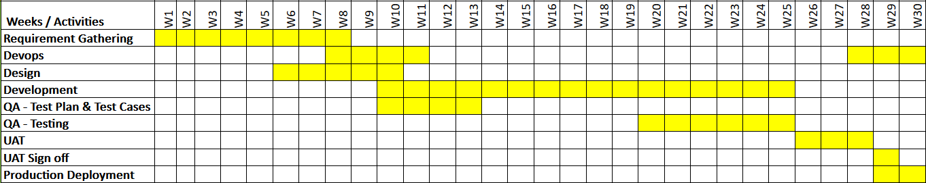

The overall timeline of the development of proposed Web Application would be around **30 weeks**

# PROJECT REPORTING AND GOVERNANCE

Following is our governance model we will be using for overall engagements for each client.

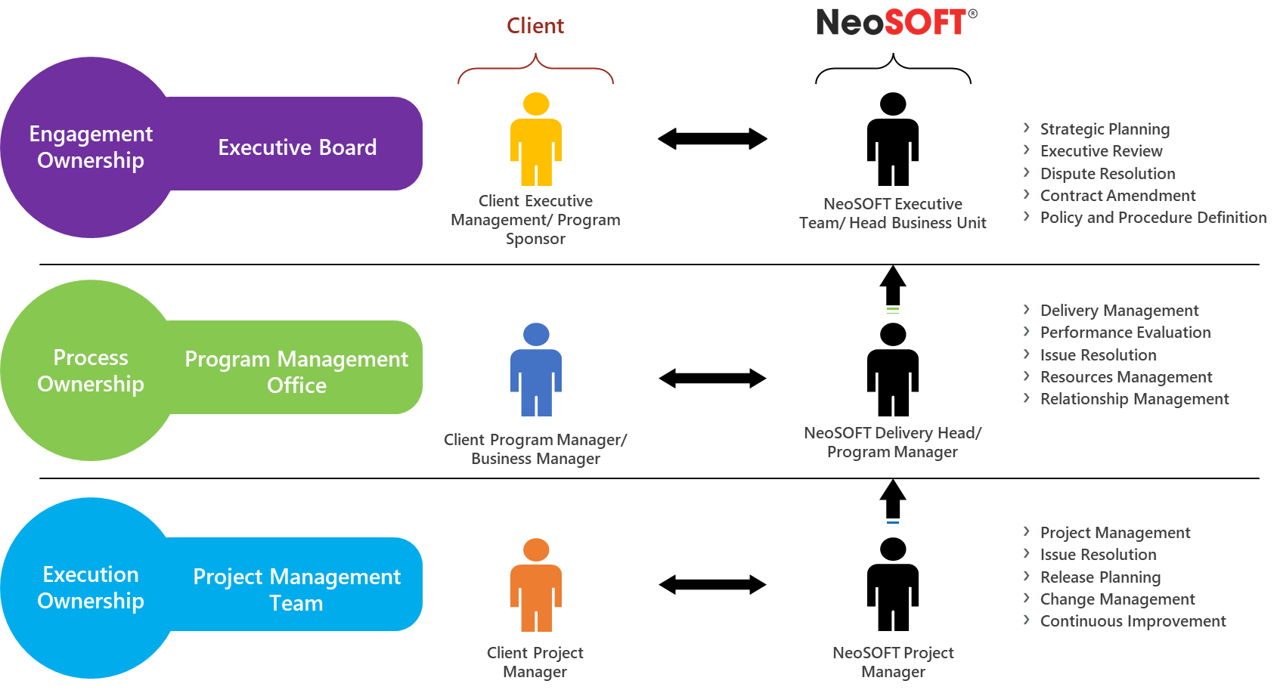

With regards to the project delivery, there will be an appointed project manager who will act as the single point of contact for all project-related communications. All emails regarding the development activity should be copied to the respective project managers. Upon Signed Off the SOW, PM will start the project Kick-off and the SOW will serve as a baseline for the successful delivery of the project, against which effort and financial progress will be routinely tracked and reported as follows;

**Weekly Status Report (WSR)** – On a weekly basis, the project manager sends a project progress report to our clients through a formalized Weekly Status Report (WSR) at a weekly project status meeting. The project manager prepares a WSR that serves as a combined RAG (red, amber, green) and RAID (risks, assumptions, issues, and dependencies) tracker, documenting all activity on the project. It is used as the main control mechanism for reporting project progress and resolving any roadblocks that prevent a project from finishing successfully.

**Timing Plans** – For each project, and phase within a project, our project managers create detailed timelines outlining each task, duration, and key milestones. This forward planning enables our project managers to efficiently and effectively utilize resources and plan and schedule review meetings with our clients. Furthermore, project plans are used to baseline and track project progress and forecast completion throughout the project.

**Change Requests** – To effectively manage change, we track changes to the scope and use change requests to update budgets and timelines based on our clients’ priorities changes throughout the project.

# RISKS AND MITIGATION PLAN

A complete risk assessment is critical to the success of any work. The risks identified here consider the current understanding of the work. Once accepted, these risks will be reviewed periodically with the project sponsors and/or decision-makers. As the project progresses, there might be more risks identified regularly which will be updated and tracked using the risk register.

The following exhibit summaries the risk and mitigation plan:

| Sr.  No. | Risk | Impact | Severity | Mitigation |
| --- | --- | --- | --- | --- |
| 1 | New Additional requirements in the Scope of Work | Overall Project | High | * If the new scope requires additional cost and time then escalation to be done. * After escalation, all parties work towards achieving timely decisions and mitigation to follow decision. |
| 2 | Miscommunications/ Delay in Clarifications | Overall Project | High | * Identify SPOC for queries clarifications. * To have communication matrix to ensure all the queries are properly clarified on time. |
| 3 | Lack of Knowledge in the existing environment | Assessment Time | High | * To have a proper KT Process and the availability of an SPOC for KT. |

# FEES AND PAYMENTS

**Total Cost (Project Implementation):**

|  |  |
| --- | --- |
| **Milestones** | **Deliverables** |
| Milestone 1 | SRS and Wireframes Creation |
| Milestone 2 | Upon UI/UX Sign Off |
| Milestone 3 | Upon completion of 50% of the total no of sprints for the mentioned scope |
| Milestone 4 | Upon completion of rest of the 50% of the total no of sprints for the mentioned scope |
| Milestone 5 | UAT Sign Off |

**CR Man day rate - 160 USD**

**Payment Schedule:**

|  |  |  |
| --- | --- | --- |
| **Payment Milestone** | **Percentage** | **Cost (USD)** |
| Upon award | 25% |  |
| Milestone 1 | 15% |  |
| Milestone 2 | 15% |  |
| Milestone 3 | 15% |  |
| Milestone 4 | 15% |  |
| Milestone 5 | 15% |  |
| **Total Cost** | 100% |  |

**Billing and Payment Terms**

NeoSOFT will raise the invoice based on the above payment schedule and **Eltizam** will pay all invoices within Seven (7) calendar days of receipt of invoice.

**Expenses**

In case a team member needs to travel at **Eltizam** ‘s request, **Eltizam** will reimburse NeoSOFT for all expenses incurred during the course of the entire visit, those expenses will be invoiced separately on actuals, unless **Eltizam** arranges for the same.

# CHANGE MANAGEMENT

**Change Request Management:**

NeoSOFT follows a structured approach towards the change request whereby the change is closely monitored to ensure that change implementations are carried out smoothly and successfully to achieve the desired output.

**Step 1: Initiating a Change**

It is the responsibility of the Change Initiator to ensure that sufficient detail exists in the request for change to ensure that the Change Manager can make an informed assessment.

Change information should include the following:

* The reason/business justification for the change
* Why the change is needed – in particular giving detailed information on implications of not implementing the change – i.e. security risks, etc.
* Known risks or impact to the business of implementing the change – consideration should also be given to the risk and impact to the business of not implementing the change
* Required resources – including people, time, and investment/costs

The status of a change at this stage of the change process will be: NEW and then AWAITING ASSESSMENT

**Step 2: Filtering & assessing a change**

All changes are filtered and assessed by the Change Manager.

Rejection of changes at assessment stage

Where a request for change has been assessed and considered inappropriate, impractical, or unjustified it should be returned to the Initiator, together with brief details of the reason for the rejection, and the request for change should record the rejection information. A right of appeal against rejection should exist, via normal management channels. The status of a change rejected at this stage of the change process will be: REJECTED BY THE CHANGE MANAGER.

Progression of changes at assessment stage

If the Change Manager completed the change assessment and considers it request viable the request for change is progress to prioritization. The status of a change at this stage of the change process will be: ASSESSED.

**Step 3: Assigning a priority to a change**

The Change Manager assigns the change a priority based on the following information:

Priority information (priority is based on how quickly the change needs to be implemented)

* Emergency – Causing loss of service or severe usability problems to a larger number of Users, a mission-critical system, or some equally serious problem. Immediate action required.
* High – Needs doing within 48 hours. Severely affecting some users, or impacting a large number of users. To be given highest priority for change building, testing, and implementation resources. (Other than emergency).
* Medium – No severe impact, but rectification cannot be deferred until the next scheduled release or upgrade. To be allocated medium priority for resources.
* Low – needs doing by the indicated date. A change is justified and necessary but can wait until the next scheduled release or upgrade. To be allocated resources accordingly.

**Step 4: Rejection of a change by the stakeholders**

If the stakeholders reject the change, the Change Manager must document, in full, the reasons for the rejection and ensure that the decision is communicated to the Change Initiator. The status of the change at this stage of the change process will be: REJECTED BY PROJECT OWNER.

**Step 5: Scheduling of a change**

Only when a change has been authorized can the Change Manager progress the change for scheduling. The Change Manager will complete the following information in the request for change form with input from other IT managers/team leaders to ensure that the appropriate resources are allocated to the change.

**Step 6: Building of a change**

Once a Change Builder(s) has been identified the change is passed to the appropriate technology expert for building. The Change Builder(s) will change the status of the change to IN BUILD.

**Step 7: Testing of a change**

Once the Change Builder(s) has completed all build activities the change is passed to a Change Tester for independent testing. The Change Tester will change the status of the change to IN TEST.

# STANDARD TERMS AND CONDITIONS

* **Proposal Validity**

Unless stated elsewhere, the proposal shall remain valid for 1 month from date of submission and subject to our written approval thereafter. However, once signed and agreed upon, the agreement shall remain valid until completion or termination of this project.

* **Project Team Location(s)**

Unless stated elsewhere, all the allocated NeoSOFT team members will be working from NeoSOFT’s location, and no resources will be working at client-location(s) for this current scope of engagement.

* **Commencement of Project**

NeoSOFT will need a minimum lead-time of 2-4 weeks before the commencement of the project. This is essential to gear up the adequate resources and carry out necessary scheduling. As this is fixed priced project, it would be NeoSOFT responsibility to complete it within the decided time frame. However, the lead time will start on receipt of the duly signed techno-commercial SOW/Proposal by Client and NeoSOFT.

* **Approvals & Acceptance Criteria**

User interaction and speedy approvals wherever identified and required plays an important role in meeting requirements accurately and timely. Once a project/project-phase is completed and NeoSOFT will provide project/project-phase release for review and approval, client will either sign off on the approval for the next phase to begin or reply to NeoSOFT, in writing i.e. within [5] days, advising what tasks must still be accomplished. If not reverted in [5] working days with proper feedback after release, release will be deemed accepted. In the event any feedback is provided after the said period of [5] working days, the same may be taken and considered on mutually agreeable terms.

* **Additional Support Services**

In case Client requires assistance in the execution of its tasks in respect of the completed assignment, NeoSOFT may undertake this on Time & Material/Managed Service/Bucket Hours basis based on mutually agreeable terms with the Client.

* **Warranty Period**

Unless stated elsewhere, NeoSOFT will provide a Warranty period of 1 month from the date of UAT Sign-off. The Warranty period support activities will be limited to bug fixes and will not entertain any enhancements or additional requirements.

* **Additional Scope of Work**

Inputs or feedback received after the UAT Sign-off would be considered as fresh requirements or would be treated as per change management procedure.

* **Interruption of Work**

Delay in work due to reasons extraneous to NeoSOFT (viz. Non-availability of Client personnel or Hardware/Software resources or data in the desired format, etc.) will automatically lead to the proportionate extension of the project duration and price. So any such extensions which incur costs need to be borne by the customer on mutually agreeable terms.

* **Expenses**

All the travel and other expenses of NeoSOFT employees incurred during any unplanned onsite support as part of the project engagement shall be borne by the Client. The expenses shall include the per diem as well. Unless specifically defined, the proposed scope of work/ price does not include any such on-site visit at the client location as NeoSOFT‘s responsibility.

* **Delay in Payment**

We are sure that our client would release the payment as per agreed payment schedules. If there is a delay of more than 15 Days due to reasons beyond our control, outstanding due amount would attract interest @1.5% per month or part of thereof.

* **Source Code Handover**

Only after the realization of the full and final payment, we will move/transfer the relevant source code to the customers’ environment.

* **General Exclusions**

Unless and otherwise stated or covered or accepted elsewhere, following are excluded:

* Procurement of Hardware & Software licenses to run application
* Integration with other/third-party software application/tools which has not been identified within scope of engagement and written in the proposal.
* Knowledge transfer to another Vendor
* Direct Knowledge transition from another Vendor
* Data Migration from existing system, if any.
* Utilities like backup, recovery, purging, etc.
* Printed stationaries, storage, and production of any graphical information like a Photograph (unless provided during requirement analysis phase)
* Vulnerability Assessment and Penetration Testing
* Ongoing/ final inspection for the developed software by a third-party provider other than customer/ user.

# OUR DETAILED PORTFOLIO

<https://marketing.neosofttech.com/>

<http://marketing.neosofttech.com/devops/>

<http://design.neosofttech.com/>

<http://marketing.neosofttech.com/mobile/>

<http://marketing.neosofttech.com/microsoft>

<http://marketing.neosofttech.com/java/>

<http://marketing.neosofttech.com/magento/>

<http://marketing.neosofttech.com/drupal/>

<http://marketing.neosofttech.com/ims/>

<http://marketing.neosofttech.com/sap/>